Mitchell House School

Online Safety Newsletter: Oct 2018

Roblox allows users to create their own virtual worlds and play with other people on a range of platforms, including mobile phones and Xboxes. By creating things, players can earn “Robux” to buy accessories, additional skills or more tools and materials to build with.

Apple device?
New Screen Time features available with iOS 12

Apple have released a software update which includes a new feature called Screen Time (under settings) which contains daily activity reports, total time spent in each app used, usage across categories of apps and how often you use your device. There is also an 'App Limits' feature so you can set a specific amount of time to be in a particular app, when this time has been reached a notification will display.

Why is this useful for you?
Through Family Sharing, you can view your child’s Activity Report from your own device and see how much time your child is spending on their device and set App Limits for them. You can also block usage at certain times e.g. bedtime. When set, notifications will not be displayed. What's really useful is that parents can choose specific apps like Phone or Books that will always be available.

More information available here: https://www.apple.com/uk/newsroom/2018/06/ios-12-introduces-new-features-to-reduce-interruptions-and-manage-screen-time/

What do I need to be aware of?

There is a chat facility within Roblox. For users aged 12 and under, Roblox automatically enforce more restricted settings so they can only directly message other friends (that they’ve accepted) but does your child know all their ‘friends’ on Roblox? Are they signed up with their right age?

Players age 12 and younger have their posts and chats filtered both for inappropriate content and behavior and to prevent personal information from being posted. Players age 13 and older have the ability to say more words and phrases, but inappropriate chat and sharing personal information should be restricted. To adjust the chat and interaction settings of your child's account:
- Click on the gear icon in the upper right corner and click Settings.
- On the right hand side of the Settings page click the Privacy option.

Users and their parents may also enable an Account PIN which requires a 4-digit code to make changes to the account.

Can I see what my child is doing on Roblox?

Roblox has several ways to see the history for certain activities. When logged in, you can view the following histories:
- Private message history
- Friends and Followers
- Virtual item purchase and trade history
- Chat history with other players

For more information, Roblox have created this parent’s guide:
https://corp.roblox.com/parents/

(Source: https://en.help.roblox.com/hc/en-us/articles/203313120-Safety-Features-Chat-Privacy-Filtering)

Time to go online together with Think you know
Games currently being played…

PUBG (PC/Xbox)
(PlayerUnknown's Battlegrounds)

This game has been rated 16+ by PEGI: This game has been rated PEGI 16 due to frequent moderate violence towards human characters and encouragement of drug use. Not suitable for persons below 16 years of age.

It’s an online multiplayer game, in which a group of students are forced to fight to the death by the government. 100 players are dropped on to the island and they quickly need to search for items, such as backpacks, body armour and guns and then try to kill each other until they are the only remaining player.

Parents need to be aware that this can be an addictive game and due to the live chat, inappropriate or offensive language may be heard.

National Online Safety have produced this brilliant guide for Parents which includes how to report users:

https://nationalonlinesafety.com/resources/platform-guides/pubg-parents-guide/

(Source: https://www.thinkuknow.co.uk/parents/articles/band-runner/)

Why not visit the Thinkuknow 8-10’s website (for 8 – 10 year olds) with your child and play their game, Band Runner together and explore the online safety advice pages together? The game is available here: https://www.thinkuknow.co.uk/8_10/

Think you know have produced some useful conversation starters and advice to help you talk to your child about staying safe online:

- Ask your child about the games, sites and apps they like to use. What do they like about them? Is there anything they don’t like?
- Play Band Runner together. You could take it in turns on one device or play at the same time on two. After playing, ask your child what they remember about Alfie’s online safety dilemmas.
- If your child enjoys playing games where they interact with people they don’t know, make sure they understand that it is not safe to share personal information like their name, school, and phone number with people they meet in the game. Explain that if anyone says anything that worries or upsets them, they should tell you or another trusted adult straight away.
- Help your child manage the privacy settings on their apps to ensure that they are only sharing things with friends they know and trust in real life. If your child likes sharing photos or videos with people they know in real life discuss safer ways they could do this e.g. sending via email, messaging service or private link.
- Find out how to block and report someone in each game, site and app they use and discuss with your child
- Tell your child that they can come to you if something goes wrong online, that they won’t be in trouble and you will be able to help.

What you need to know about Live streaming
Go online together!

Why not watch this video from Common Sense with your child (recommended school year 7 – 9) and then talk about it together?

https://youtu.be/wyjd73tUXig

This is an animated music video which raps about the hazards of oversharing online and is designed to make you think about your digital footprint. Here are some questions that you could ask your child?
- Do you use privacy settings on all your social media accounts?
- How do privacy settings help you manage your digital footprint?

National Online Safety has produced this excellent guide for parents outlining what you need to know about Live streaming (when you broadcast real-time video). There are lots of positives including watching live concerts and speaking with friends but you need to be aware of the potential dangers such as chatting with strangers so you can talk about it with your children. Download it here: https://nationalonlinesafety.com/resources/platform-guides/live-streaming-guide-for-parents/

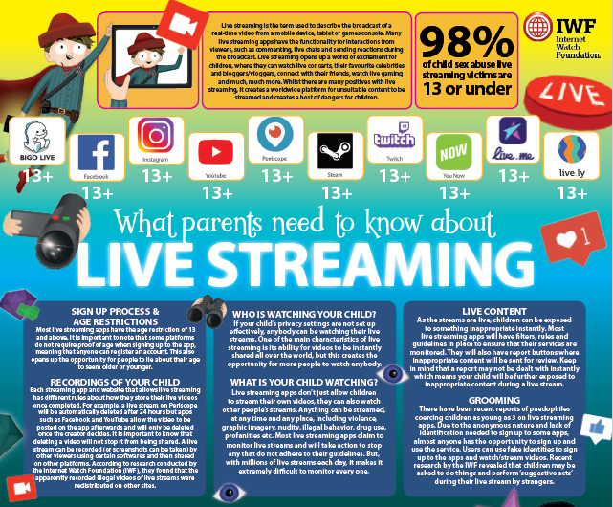

Apps to learn about numbers
Instagram

Instagram are rolling out a number of new safety measures (we included some of these in our September newsletter). They have now released a Parent's guide to help you talk to your child about Instagram. It's a really useful guide and includes how to manage privacy, interactions and their time spent on Instagram as well as 10 questions to help you start a conversation.

https://wellbeing.instagram.com/parents

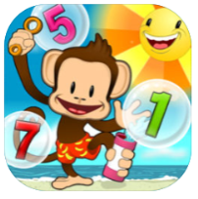
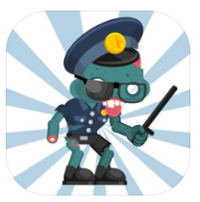
Operation Math
Code Squad
£2.99 (iOS)
£2.69 (Google)
Monkey Math School Sunshine
£1.99 (iOS)
£1.79 (Google)
Math Vs Zombies
Free (iOS)
Free (Google)

Sumdog
Free (iOS)
Free (Google)

